

**Submitted by**

***M. Azeem (310)***

***Umar Farooq (309)***

***M.Maaz Usman (296)***

***Osman Asghar (290)***

**Section : G-2**

**Submitted to : *MAAM Amina Saud***

**Assignment topic : Project Proposal**

**Discipline : BS(Hons)Computer Science**

**Object-Oriented Programming (Project Proposal)**

* **Write a Java program based on the following scenario:**

**Abstract**

Hospitals currently use a manual system for the management and maintenance of critical the current system requires numerous **paper forms**, with data stores, spreads throughout the hospital management infrastructure. Forms are often lost in transit between departments requiring a [broad](https://www.bing.com/search?q=define+broad&FORM=DCTRQY) auditing process to ensure that no vital information is lost. Multiple copies of the same information exist in the hospital and may lead to inconsistencies in data in various data stores.

A significant part of the operation of any hospital involves the management and timely recovery of **great volumes of information**. This information typically involves, patient personal information and medical history, staff information, room and ward scheduling, staff scheduling, operating theater scheduling, and various facilities. All of this information must be managed in an efficient and automate the management of the hospital making it more efficient and error-free.

**Functionality/Scenario:**

This project name is **Hospital management system (HMS)** also dealing **with corona patients** and this is a **parent class** of our project. This program used by his/ her **Admin, Doctors, and Workers** to facilitate his/her patients both have their **login systems (The First login is done by Admin in GUI Form if GUI logins are wrong so the Program doesn't run)**. But This program starts only by admin with the help of the login system. The important functionality in the login system (**Runtime change password**) Concept of **Runtime Polymorphism**. Forgetting is human nature. None can deny this fact. There might be possible that a user is trying to access the system after a long period, and he/she may forget his / her registered login id or password or both of them. I have taken the users' that concern too into the account so that it is smoother for him/her to recover the login id or password according to need (Try to use-Exceptional Handling). In this project, we have also a **parking system** for his/her customers as well as an ambulance **emergency** parking side **(Child class of HMS)**. In this Hospital management system, we have **Six Departments** and each department have their specific area and specific **block number** that tells by the receptionist. Six departments **(Eye, Cancer, Corona, Operation theater, Cardiac, Normal checkup (Child classes of HMS))** Each department contains **(Pharmacy, Pathology Lab, and their Board).**

This **receptionist (Child Class of both dept.)** will maintain the **time table** of each doctor. This time table of each doctor will be **available** to the patients **(Use Full functions of file handling)**. The other task the receptionist can do is, filtering the appointments based on doctors and periods so that it is easy to access the appointment record (File Handling). A patient can make an appointment with the available doctors. **The receptionist** Fee is 500 for ordinary patients or the VIP patient fee is 2000. **The receptionist** makes a report of patient biodata (Name, CNIC Gender). Make a class for Notice Board use only Add or View function and don’t use append constructor of File Class.

There has a **Bank Management System** in this program all the revenue is saved and payment is done by each department Receptionist. Pharmacy (Medicine Payment Done by Pharmacy Admin and save in Hospital revenue). Patient bills are also saved in Hospital Revenue. As well as Lab test payment is done by Lab Admin and save in Hospital Revenue.

**(Patient. Child class of both Dept.**) Opening or closing time for patient families. The time table will be shown which is directed by the receptionist. When the doctor approves the appointment, the patient will be notified **(Use Receptionist File Reader {for loop (if (Time=user time)} use System time to find Doctor}**. The patient can view the doctor's report about his / her appointment and his / her prescription details. Thus, the patient can know what has happened to him/her and how she or he should take care of herself or himself (Make a report and save in file). If there are some serious health issues and the patient is needed to be admitted into the hospital, the bed would be allotted to him or her {If (Normal) else (Emergency)}. The patient can view the information about the allotted bed. **(Make a separate class for corona patients)** If the user is corona patient so use isolation ward. 14 Days Quarantine Regular checkup and crowd fish for corona patients. Ventilators are used in Emergency cases **{if (Normal Patient) else (Emergency Patient)}**. There will be separate space for VIP Patients. More facilities for VIP patients (Separate room, Special Food) and **Receptionist contains** extra charges. Make a **class** for **patient Death** **(Time, Name, Cause, Department). Make a class for patient billing (Total bill with a name for each dept).**

Make one class for **Salary Calculation** for all **Doctors** as well as **Admin** and all **Paramedical staff (Child class of HMS)**. **Utility bills** update monthly and the total bill is saved in File **(Child class of HMS)**. Make a class for **Head of the Workers** that tells about the specific work of each worker **(Use Every important worker)**. Make a class for all **Hospital Nurses** (ID, Name **(Child class of HMS)**). Make a class for **Pathology Lab** (ID, Test Name **(Child class of HMS)**). Make a class for **Hospital Doctors** (ID, Name & Dept name **(Child class of HMS)).** Make a class for **VPI Room and normal Room** and number or **ICU, Ventilators** in Hospital.

**(All Data is saved in a file and Able to Add, View, Delete, Search, Update in a file)**

### Project scope

### In Pakistan, many hospitals don't have a patient record in proper from this project helps to safe the patient data in the file and use it anytime, anywhere.

### Project development Tools

Eclipse

MS Word

Powerpoint

Git Hub (Communication)

JAVA (Language)

**Class Diagram**

**UML CLASS DIAGRAM** gives an overview of a software system by displaying classes, attributes, operations, and relationships. This Diagram includes the **class name, attributes, and operations** in separate designated compartments.

* A high-level view of an application
* Types of relationships among classes

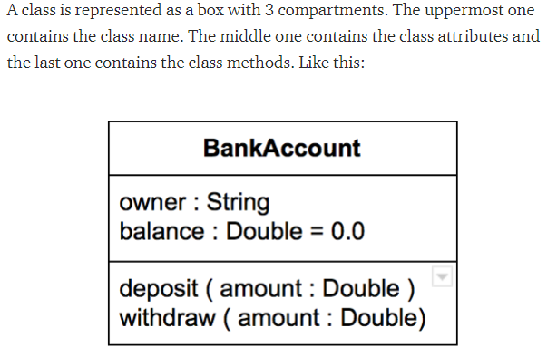

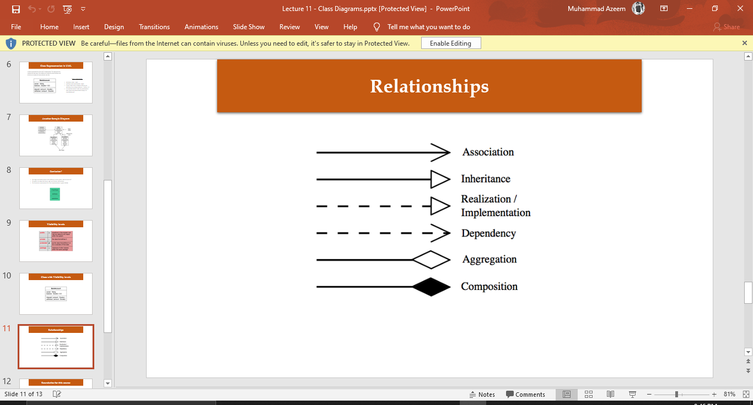

In This Class Diagram. I use this sign for inheritance and ----> this for implementation

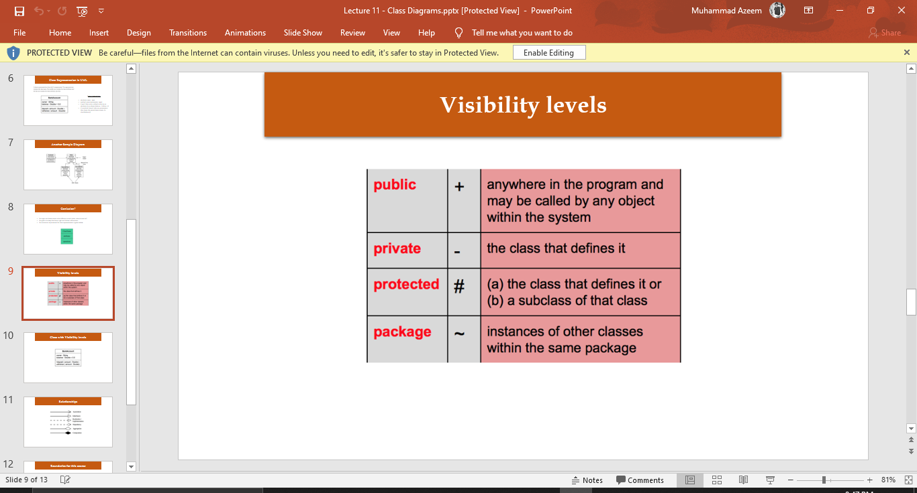

|  |
| --- |
| Hospital Management System |
| -HospitalName: String  -HospitalLoaction: String  -HospitalNumber:long |
| +SetName (Name:int)  +SetLocation(Location:int)  +SetNumber (Number:int)  +Login ()  +insert ()  +view () |

|  |
| --- |
| Parking |
| -CarNumber:String  -CarTokan:String |
| +SetNumber (Number:int)  +SetTokan(Tokan:int)  +insert ()  +view ()  +Search ()  +Delete ()  + Update () |

|  |
| --- |
| ***(Abstract) Eye Department*** |
| -DeptBlockNumber:int  -HeadName:String |
| +SetHeadName (HName:String)  +SetDeptBlockNo (Number:int)  +Login ()  +***DoctorTimeTable();***  +insertNew ()  +view () |

|  |
| --- |
| **Receptionist** |
| -DoctorsTime:int  -DoctorName:String |
| +***DoctorTimeTable() //overriding***  ***+insertNew ()***  ***+view ()***  +Search ()  +Delete ()  +Update ()  +EDFindDoctor() |

|  |
| --- |
| ***Interface ReceptionistR*** |
| ***+TotalDoctors:int=13*** |
| public void DoctorTimeTable() |

---------- >

|  |
| --- |
| Hospital Management System |

|  |
| --- |
| Patients |
| -PatientTokenNo:int  -PatientName:String |
| +PatientADD()//Attach_10_Classes  +PatientPayment(int TBill)  +Discharege()  +VIPFood ()  +VIPRoom ()  +insert ()  +view ()  +Search ()  +Delete ()  + Update () |

|  |
| --- |
| ***(Abstract) CancerDepartment*** |
| -DeptBlockNumber:int  -HeadName:String |
| +SetHeadName (HName:int)  +SetDeptBlockNo (Number:int)  +Login ()  +***DoctorTimeTable();***  +insertNew ()  +view () |

^

|  |
| --- |
| **Receptionist** |
| -DoctorsTime:int  -DoctorName:String |
| +***DoctorTimeTable() //overriding***  ***+insertNew ()***  ***+view ()***  +Search ()  +Delete ()  +Update ()  +CDFindDoctor() |

|

|

|  |
| --- |
| ***Interface PatientPayment*** |
| ***+CoronaDoctorsPayment:int=5000***  ***+CardicDoctorPayment:int=2000***  ***+EyeDocotrPayment:int=1000***  ***+GernalDoctorPayment:int=500***  ***+CancerDoctorPayment:int=8000***  ***+OperationDoctorPayment:int=10000*** |
|  |

^

|

|

|  |
| --- |
| ***Interface ReceptionistR*** |
| ***+TotalDoctors:int=13*** |
| public void DoctorTimeTable(); |

|  |
| --- |
| Hospital Management System |

|  |
| --- |
| ***(Abstract) CoronaDepartment*** |
| -DeptBlockNumber:int  -HeadName:String |
| +SetHeadName (HName:int)  +SetDeptBlockNo (Number:int)  +Login (Password:int)  +***DoctorTimeTable();***  ***+DoctorKit ();***  +insertNew ()  +view () |

|  |
| --- |
| **NoticeBoard** |
| -Message: String |
| +SetNoticeBoard ***()***  *+InsertNew ()*  *+ View ()* |

|  |
| --- |
| **Receptionist** |
| -DoctorsTime:int  -DoctorName:String |
| +***DoctorTimeTable () //overriding***  ***+insertNew () //overriding***  ***+DoctorKit () //overriding***  ***+view ()*** ***//overriding***  +Search ()  +Delete ()  + Update ()  +CDFindDoctor(); |

|  |
| --- |
| **IsolationWard** |
| -Quarantine: int  -Symptom: String |
| +QuarantineDuration ***()***  *+Symptom ()*  *+Food ()* |

^

|

|

|  |
| --- |
| ***Interface ReceptionistR*** |
| ***+TotalDoctors:int=13*** |
| **+public void DoctorTimeTable()** |

|  |
| --- |
| Hospital Management System |

|  |
| --- |
| ***CardiacDepartment*** |
| -DeptBlockNumber:int  -HeadName:String |
| +SetHeadName (HName:int)  +SetDeptBlockNo (Number:int)  +Login ()  +***DoctorTimeTable();***  +insertNew ()  +view () |

|  |
| --- |
| ***(Abstract) GernalCheckUpDepartment*** |
| -DeptBlockNumber:int  -HeadName:String |
| +SetHeadName (HName:int)  +SetDeptBlockNo (Number:int)  +Login ()  +***DoctorTimeTable();***  +insertNew ()  +view () |

|  |
| --- |
| **Receptionist** |
| -DoctorsTime:int  -DoctorName:String  -Ventilator:int |
| +***DoctorTimeTable () //overriding***  ***+insertNew ()***  ***+view ()***  +Search ()  +Delete ()  +Update ()  +RCNFindDoctor() |

|  |
| --- |
| **Receptionist** |
| -DoctorsTime:int  -DoctorName:String  -Ventilator:int |
| +***DoctorTimeTable () //overriding***  +insertNew () ***//overriding***  +view () ***//overriding***  +Search ()  +Delete ()  + Update ()  +GDFindDoctor() |

^

|

|

|  |
| --- |
| ***Interface ReceptionistR*** |
| ***+TotalDoctors:int=13*** |
| **+public void DoctorTimeTable()** |

|  |
| --- |
| Hospital Management System |

|  |
| --- |
| ***(Abstract) OperationDepartment*** |
| -DeptBlockNumber:int  -HeadName:String |
| +SetHeadName (HName:int)  +SetDeptBlockNo (Number:int)  +Login ()  +***DoctorTimeTable();***  +insertNew ()  +view () |

|  |
| --- |
| **Rooms** |
| -TotalLocalRooms:int  -TotalVIPRooms: int  -TotalICU:int |
| +SetTotalLocalRooms (LRoom:int)  +SetTotalVIPRooms (VRoom:int)  +SetTotalICU (RICU:int)  +LoginReceptionist ()  +insertNew ()  +view () |

|  |
| --- |
| **Receptionist** |
| -DoctorsTime:int  -DoctorName:String  -Ventilator:int |
| +***DoctorTimeTable () //overriding***  ***+insertNew () //overriding***  ***+view ()*** ***//overriding***  +***NoOfVentilators()*** ***//overriding***  +Search ()  +Delete ()  + Update ()  +ODFindDoctor() |

|  |
| --- |
| **HospitalNurses** |
| -TotalNurses:int  -NursesID:int |
| +SetTotalNurses (TNurses:int)  +SetIDNurses (ID:int)  +SetNameNurses (NName:String)  +LoginReceptionist ()  +insertNew ()  +view ()  +Search ()  +Delete ()  +Update () |

^

|

|

|  |
| --- |
| ***Interface receptionist*** |
| ***+TotalDoctors:int=13*** |
| **+public void DoctorTimeTable()** |

^

|

|

|  |
| --- |
| ***Interface List*** |
| ***+HospitalDoctors:int=78***  ***+HospitalNurses:int=78***  ***+HospitalWorkers:int=78*** |
|  |

|  |
| --- |
| Hospital Management System |

|  |
| --- |
| **HospitalDoctors** |
| -TotalDoctor:int  -TotalName:String  -DoctorID:int |
| +SetTotalDoctor (TDoctor:int)  +SetIDDoctor (ID:int)  +SetNameDoctor (DName:String)  +LoginReceptionist ()  +insertNew ()  +view ()  +Search ()  +Delete ()  +Update () |

|  |
| --- |
| **HospitalWorkers** |
| -TotalWorkers: int  -WorkerID:int  -WorkerName: String  -TypeOfJob: String |
| +SetTotalWorkers (TWorkers:int)  +SetIDWorkers (ID:int)  +SetNameWorkers (NName:String)  +SetJobType (JobType:String)  +LoginReceptionist ()  +insertNew ()  +view ()  +Search ()  +Delete ()  +Update () |

^-__\

\

\ ^

\ |

|  |
| --- |
| **UtilityBill** |
| -BillName: String  -Month: int  -Day: int  -Year: int |
| +SetBillName (BName:String)  +SetDay (Day:int)  +SetMonth (Month:int)  +SetYear (Year:int)  +insert ()  +view ()  +Search ()  +Delete ()  +Update ()  +PayUtilityBills(); |

\ |

|  |
| --- |
| ***Interface List*** |
| ***+HospitalDoctors:int=78***  ***+HospitalNurses:int=78***  ***+HospitalWorkers:int=78*** |
|  |

\

---|>

|  |
| --- |
| Hospital Management System |

|  |
| --- |
| ***(Abstract) LAB*** |
| -HeadOfLab: String=Moazam  -ContactNo:long=03114247843 |
| ***+SetTestName (TName:String);***  ***+SetPatientName (PName:String);*** |

|  |
| --- |
| **PathologyLab** |
| -TestName:String  -TokenID:int  -PatientName:String |
| ***+SetTestName (TName:String)***  +SetTokenID (ID:int)  ***+SetPatientName (PName:String)***  +insertNew ()  +view ()  +Search ()  +Delete ()  +Update ()  +LabPayment() |

|  |
| --- |
| ***(Abstract) PAY*** |
| -Accountant: String=Moazam  -ContactNo: long=03244064060 |
| ***+DoctorPay ();***  ***+NursePay ();***  +***WorkerPay ();***  ***+GradTotal();*** |

|  |
| --- |
| **DNWPay** |
| -GrandTotal:String  -DTotal:int  -NTotal:String  -WTotal:long |
| +LoginAdmin(Password:int)  ***+DoctorPay ()***  ***+NursePay ()***  +**WorkerPay ()**  ***+GradTotal()***  ***+*Bank()** |

|  |
| --- |
| Hospital Management System |

|  |
| --- |
| **Login extends JFrame** |
| -Img_UserName:Image  -Img_UserLogo:Image  -Img_UserPassword:Image  -Img_UserLogin:Image  -ControlPane:JFrame  -txtPassword: JPasswordField  -LoginPassword:JLabel |
| ***+Login()*** |

|  |
| --- |
| **Exit extends JFrame** |
| -ContentPane:JPane  -img_Exit: Image |
| ***+Exit()*** |

|  |
| --- |
| **Pharmacy** |
| -MedicineName [] :String  -TokenID [] :int  -PatientName [] :String |
| ***+DisplayManager()***  ***+SGPharmacy()***  ***+PinsertNew()***  ***+MadicineBuy()***  ***+MadicineBuy2()***  +MedicineInsertNew ()  +MedicineView ()  +MedicineSearch ()  +MedicineDelete ()  +MedicineUpdate () |